Bahria University,

Karachi Campus



COURSE: CSC-113 COMPUTER PROGRAMMING

TERM: FALL 2019, CLASS: BSE- 1 (B)

Submitted By:

M MUAZ SHAHZAD 02-131202-081

(Name) (Reg. No.)

Submitted To:

Engr. Adnan ur rehman/ Engr. Ramsha Mashood

Signed Remarks: Score:

INDEX

|  |  |  |  |  |
| --- | --- | --- | --- | --- |
| SNO | DATE | LAB NO | LAB OBJECTIVE | SIGN |
| 01 | 15-Dec-2020 | 10 | **2D Arrays** |  |
|  |  |  |  |  |
|  |  |  |  |  |
|  |  |  |  |  |
|  |  |  |  |  |
|  |  |  |  |  |
|  |  |  |  |  |
|  |  |  |  |  |
|  |  |  |  |  |
|  |  |  |  |  |
|  |  |  |  |  |
|  |  |  |  |  |
|  |  |  |  |  |
|  |  |  |  |  |
| SNO | DATE | LAB NO | LAB OBJECTIVE | SIGN |
|  |  |  |  |  |
|  |  |  |  |  |
|  |  |  |  |  |
|  |  |  |  |  |
|  |  |  |  |  |
|  |  |  |  |  |
|  |  |  |  |  |
|  |  |  |  |  |
|  |  |  |  |  |
|  |  |  |  |  |
|  |  |  |  |  |
|  |  |  |  |  |
|  |  |  |  |  |
|  |  |  |  |  |
|  |  |  |  |  |

Bahria University,

Karachi Campus



LAB EXPERIMENT NO.

10

LIST OF TASKS

|  |  |
| --- | --- |
| TASK NO | OBJECTIVE |
| 01 | Enter the first matrix and then display it. Secondly, enter the second matrix and then display it. In the result by apply 2D arrays show Addition, subtraction of 2 matrixes. |
| 02 | Take N number of user data input and make sure N is greater than 10, which contain name of the user, his/her nationality, and his/her eye color. You must show the max color of eye in each country |
| 03 | Make a program in C# in which take no. of items, price of items, quantity of items and name of items as input from the user and give the discount according to the following conditions (Use 2D Array):   * 1. If from rice give discount of 30%.   2. Else if the total amount is greater than 50,000 and less than 100,000 give discount of 20%.   3. Else if the total amount is greater than 100,000 give discount of 30%. |
|  |  |
|  |  |
|  |  |
|  |  |
|  |  |

Submitted On:

22/12/2020

(Date: DD/MM/YY)

**Task No. 1: Enter the first matrix and then display it. Secondly, enter the second matrix and then display it. In the result by apply 2D arrays show Addition, subtraction of 2 matrixes.**

**Solution:**namespace ConsoleApp3

{

class Program

{

static void Main(string[] args)

{

Console.WriteLine("Name: M Muaz Shahzad ");

Console.WriteLine("BSE 1B/ 02-131202-081 ");

int i, j, l, p;

Console.Write("\nEnter The Number Of Rows: ");

l = Convert.ToInt32(Console.ReadLine());

Console.Write("\nEnter The Number Of Columns: ");

p = Convert.ToInt32(Console.ReadLine());

int[,] a = new int[l, p];

Console.WriteLine("\nEnter First Matrix Numbers: ");

for (i = 0; i < l; i++)

{

for (j = 0; j < p; j++)

{

a[i, j] = int.Parse(Console.ReadLine());

}

}

int[,] b = new int[l, p];

Console.WriteLine("Enter Second Matrix Numbers: ");

for (i = 0; i < l; i++)

{

for (j = 0; j < p; j++)

{

b[i, j] = int.Parse(Console.ReadLine());

}

}

Console.WriteLine("First matrix is: ");

for (i = 0; i < l; i++)

{

for (j = 0; j < p; j++)

{

Console.Write("{0,7}", a[i, j] + "\t");

}

Console.WriteLine();

}

Console.WriteLine("Second Matrix is : ");

for (i = 0; i < p; i++)

{

for (j = 0; j < p; j++)

{

Console.Write("{0,7}", b[i, j] + "\t");

}

Console.WriteLine();

}

Console.WriteLine("Matrix Subtraction is : ");

int[,] c = new int[l, p];

for (i = 0; i < l; i++)

{

for (j = 0; j < p; j++)

{

c[i, j] = a[i, j] - b[i, j];

}

}

for (i = 0; i < l; i++)

{

for (j = 0; j < p; j++)

{

Console.Write("{0,7}", c[i, j] + "\t");

}

Console.WriteLine();

}

Console.WriteLine("Matrix Addition is : ");

int[,] d = new int[l, p];

for (i = 0; i < l; i++)

{

for (j = 0; j < p; j++)

{

d[i, j] += a[i, j] + b[i, j];

}

}

for (i = 0; i < l; i++)

{

for (j = 0; j < p; j++)

{

Console.Write("{0,7}", d[i, j] + "\t");

}

Console.WriteLine();

}

Console.ReadKey();

}

}

}

**Output: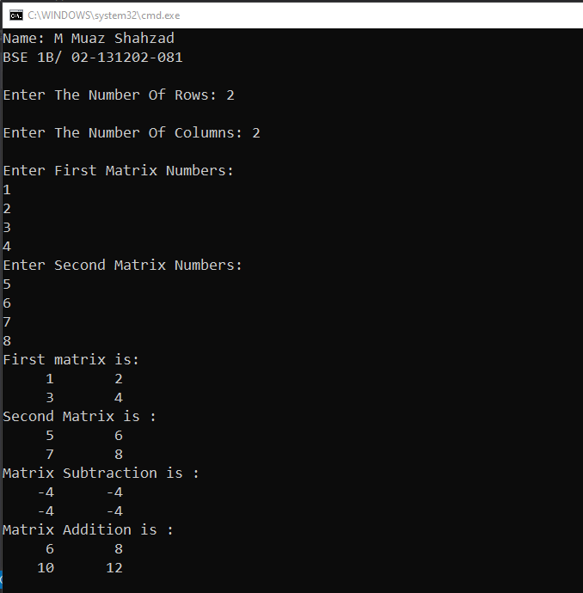 Task No. 2: Take N number of user data input and make sure N is greater than 10, which contain name of the user, his/her nationality, and his/her eye color. You must show the max color of eye in each country**

**Solution:**namespace eYE_cOLOURS

{

class Program

{

static void Main(string[] args)

{

string[,] input;

Console.Write("Enter Num Greater Than 10 : ");

int n = Convert.ToInt32(Console.ReadLine());

input = new string[n, n];

for (int p = 0; p < n; p++)

{

Console.WriteLine("Enter Name: ");

input[p, 0] = Console.ReadLine();

Console.WriteLine("Enter Nationality:");

input[p, 1] = Console.ReadLine();

Console.WriteLine("Enter Eye Color:");

input[p, 2] = Console.ReadLine();

}

Console.WriteLine("=============================================================================================");

Console.WriteLine("{0,50} {1,20} {2,20}", "Name","Nationality","Eye Color");

Console.WriteLine("=============================================================================================");

for (int p = 0; p < n; p++)

{

Console.WriteLine("{0,50}{1,20}{2,20}", input[p, 0], input[p, 1], input[p, 2],"|");

}

Console.WriteLine("=============================================================================================");

Console.ReadLine();

}

}

}

**Output:**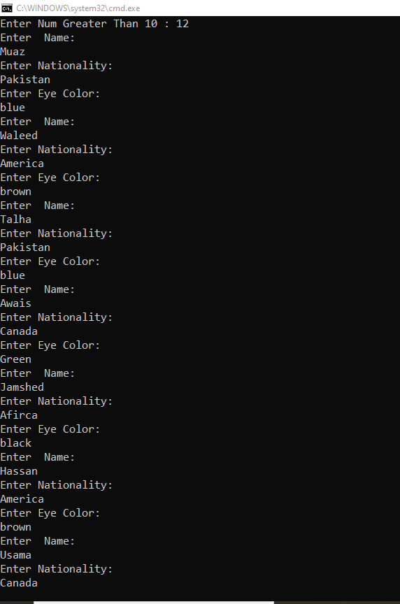  
  
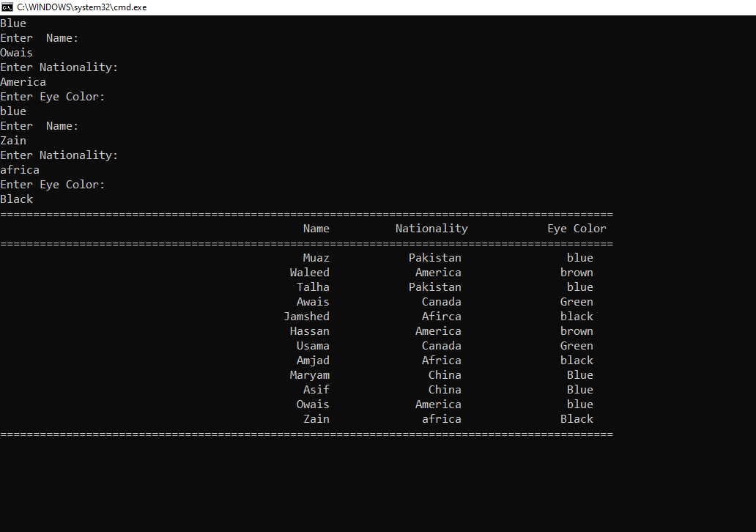  
  
  
  
  
  
  
  
  
  
  
  
  
  
  
  
  
  
  
  
  
  
  
**Task No. 3: Make a program in C# in which take no. of items, price of items, quantity of items and name of items as input from the user and give the discount according to the following conditions (Use 2D Array):**

1. **If from rice give discount of 30%.**
2. **Else if the total amount is greater than 50,000 and less than 100,000 give discount of 20%.**
3. **Else if the total amount is greater than 100,000 give discount of 30%.**

**Solution:**namespace Rice_discount

{

class Program

{

static void Main(string[] args)

{

string[,] info;

double discount = 0;

double totalamount = 0;

Console.Write("Enter Number Of Items You Want To Buy : ");

int z = Convert.ToInt32(Console.ReadLine());

info = new string[z, 4];

for (int i = 0; i < z; i++)

{

Console.WriteLine("\nITEM NO: " + (i + 1));

Console.WriteLine("Enter Quantity of Item:");

info[i, 0] = Console.ReadLine();

Console.WriteLine("Enter Price of Item:");

info[i, 1] = Console.ReadLine();

Console.WriteLine("Enter Name of Item:");

info[i, 2] = Console.ReadLine();

}

Console.WriteLine("{0,15}{1,15}{2,15}{3,15}", "Quantity", "Price", "Item", "Discount");

for (int i = 0; i < z; i++)

{

if (info[i, 2] == "rice")

{

info[i, 3] = "0.3";

}

else

{

info[i, 3] = "0";

}

Console.WriteLine("{0,15}{1,15}{2,15}{3,15}", info[i, 0], info[i, 1], info[i, 2], info[i, 3]);

totalamount += (Convert.ToInt32(info[i, 0]) * Convert.ToInt32(info[i, 1])) - (Convert.ToInt32(info[i, 0]) * Convert.ToInt32(info[i, 1])) * Convert.ToDouble(info[i, 3]);

}

if (totalamount > 50000 && totalamount < 100000)

{

discount = .2;

}

else if (totalamount > 100000)

{

discount = .3;

}

Console.WriteLine("\n\tTotal Amount : " + totalamount);

Console.WriteLine("\tDiscount : " + discount * totalamount);

Console.WriteLine("\tFinal Amount : " + (totalamount - discount * totalamount));

Console.ReadLine();

}

}

}

**Output:**